Morrison County Drop In Center
November 2025
Pam’s hours are Monday – Friday 9:00am-2:00pm. If you need her any other time, please put a note in her door she will get back to you as soon as possible.

Vikings schedule for November
2nd - Lions
9th –Ravens
16th – Bears
23rd – Packers
30th - Seahawks
Pot luck November 20th at 12pm – 1pm please bring a dish to share. Please call the Drop in Center by November 15 to let us know how many to cook for.

Remember the November Birthdays
7th-Fran

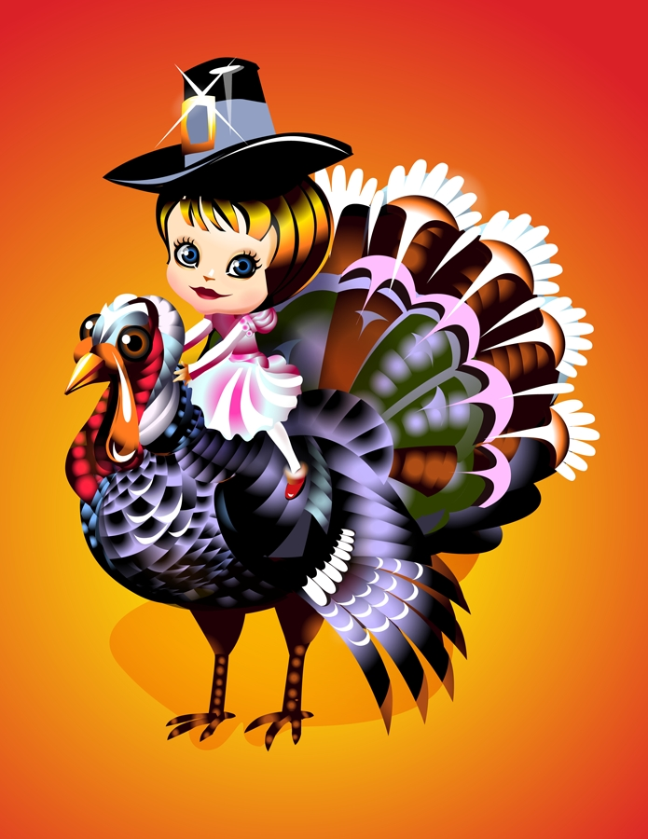
Thanksgiving is November 27, 2025. We will be CLOSED that day. We will be closed November 28, 2025 for black Friday.

Peer meeting is Thursday November 6th at 10:30am please come join us for this meeting as you the peers get to express your opinions and concerns.



6  19  27  28 | Peer Meeting 10:30am  Pot Luck  THANKSGIVING Day CLOSED  Black Friday CLOSED

